Multivariate bias correction improves inter-station dependence relative to QDM in multi-site daily precipitation across a coastal gauge network in Thailand
Surasit Punyawansiri^{1,*}
¹Office of Water Management and Hydrology, Royal Irrigation Department, Bangkok, Thailand
*Corresponding author: Surasit.pun@thaimooc.ac.th
Article type: Research article

Abstract
Bias correction of climate-model precipitation is usually evaluated station by station, although distributed hydrological applications also require realistic dependence among gauges. We compared N-dimensional multivariate bias correction (MBCn), quantile delta mapping (QDM), and uncorrected output for 12 daily rain gauges on the western Gulf of Thailand coast and seven CMIP6 models. Methods were calibrated on 1981–2000 and evaluated independently on 2001–2014. The Q2.1 analysis pipeline was revised to enforce the 12-station network before fitting, use a calendar-month block MBCn formulation, standardize the joint-distribution diagnostic, and separate prespecified primary correlation endpoints from secondary diagnostics. The previous manuscript numerical results are not carried forward because these implementation changes require a complete re-fit and re-evaluation from the original model data. The study therefore retains the methodological hypothesis that MBCn should modify inter-station dependence while preserving the QDM marginal values, but quantitative claims about the magnitude, significance, convergence, and future-signal differences must be re-estimated from the Q2.1 run.
Keywords: multivariate bias correction; MBCn; inter-station dependence; multi-site precipitation; CMIP6
REANALYSIS STATUS — Q2.1 IMPLEMENTATION
All pre-Q2.1 numerical results have been withdrawn pending a complete rerun with the original seven-GCM daily model data. This version is scientifically corrected in method and reporting logic but is not a final numerical-results manuscript.

1. Introduction
Global climate models remain too coarse for direct use at catchment and station scales, and their daily precipitation contains systematic errors in both occurrence and intensity [1]. Distribution-based bias correction is therefore standard in hydrological climate-impact studies [2], [3]. Quantile delta mapping (QDM) is widely used because it adjusts the full distribution at a site while preserving the model-projected relative change at each quantile [4]. This is usually sufficient when the analysis treats each gauge independently.
QDM does not directly control relationships among gauges because each site is corrected independently. This limitation matters when corrected fields drive distributed hydrological models, joint flood analyses, or assessments of spatially extensive droughts and storms. Accurate marginal distributions can coexist with an unrealistic joint structure, and such errors propagate into analyses of compound and spatially concurrent extremes [5].
Multivariate methods address the joint distribution explicitly. Examples include rank-based resampling [6], optimal transport [7], and N-dimensional multivariate bias correction (MBCn) [8]. MBCn repeatedly rotates the multistation field, quantile-maps each rotated component to the corresponding observations, and reverses the rotation; a final step reinstates the QDM marginal values at each gauge. Comparative studies show that multivariate adjustment can improve dependence while introducing method-specific trade-offs [9], and regional applications confirm the relevance of evaluating spatial as well as marginal behaviour [10].
The final rank-substitution step determines how QDM and MBCn should be compared. Because MBCn restores the QDM values at every gauge, the two methods must be identical for distribution-based single-site diagnostics. Their added value can therefore be judged only with diagnostics that measure dependence among gauges.
The spatial organisation of rainfall extremes is both consequential and uncertain under climate change [11]. CMIP6 studies have evaluated precipitation change across mainland Southeast Asia [12]-[14] and Thailand [15]-[18], while recent work has compared correction methods in multistation settings [19]. However, few studies combine an independent validation period with several complementary dependence diagnostics in one gauge-network experiment. We therefore ask: once single-site performance is fixed by construction, how much does MBCn improve the joint behaviour of a coastal gauge network, and does it compromise numerical stability or the projected quantile-change signal?

2. Materials and Methods

2.1 Study area and rain-gauge network
Twelve daily rain gauges in Prachuap Khiri Khan Province, on the western shore of the Gulf of Thailand, provide the observations (Table 1 and Figure 1). Each record is complete from 1 January 1981 to 31 December 2014. Mean annual precipitation ranges from approximately 944 to 1,376 mm, and wet-day frequency varies markedly across the network. This spatial contrast provides a demanding test of whether correction preserves local distributions while improving network dependence.
Coordinates and elevations were obtained from the project metadata archive. Figure 1 locates the gauges within Prachuap Khiri Khan Province; the elevation background and national inset provide geographic context only and are not used in the analysis.
Table 1. Characteristics of the twelve rain gauges, 1981–2014.

Station | Latitude (°N) | Longitude (°E) | Elevation (m) | Mean annual rainfall (mm) | Wet-day frequency (%)
500001 | 12.370 | 99.950 | 8 | 983.70 | 22.23
500002 | 11.180 | 99.550 | 0 | 1,376.20 | 33.73
500003 | 12.020 | 99.900 | 0 | 1,100.00 | 22.93
500004 | 11.470 | 99.650 | 0 | 1,106.00 | 26.34
500005 | 11.600 | 99.680 | 6 | 1,147.20 | 47.96
500006 | 11.620 | 99.670 | 24 | 1,203.10 | 49.77
500007 | 11.900 | 99.780 | 24 | 1,133.60 | 48.66
500008 | 12.530 | 99.550 | 128 | 1,206.30 | 62.63
500009 | 12.220 | 99.870 | 13 | 1,176.50 | 60.15
500201 | 11.830 | 99.830 | 64 | 1,108.20 | 24.70
500202 | 12.590 | 99.960 | 0 | 944.10 | 21.53
500301 | 12.580 | 99.730 | 106 | 1,064.80 | 25.33
Coordinates (WGS84) and elevations are from the project metadata archive; rainfall statistics are computed from the gap-free observed daily record. A wet day is defined throughout as at least 1 mm of rainfall.
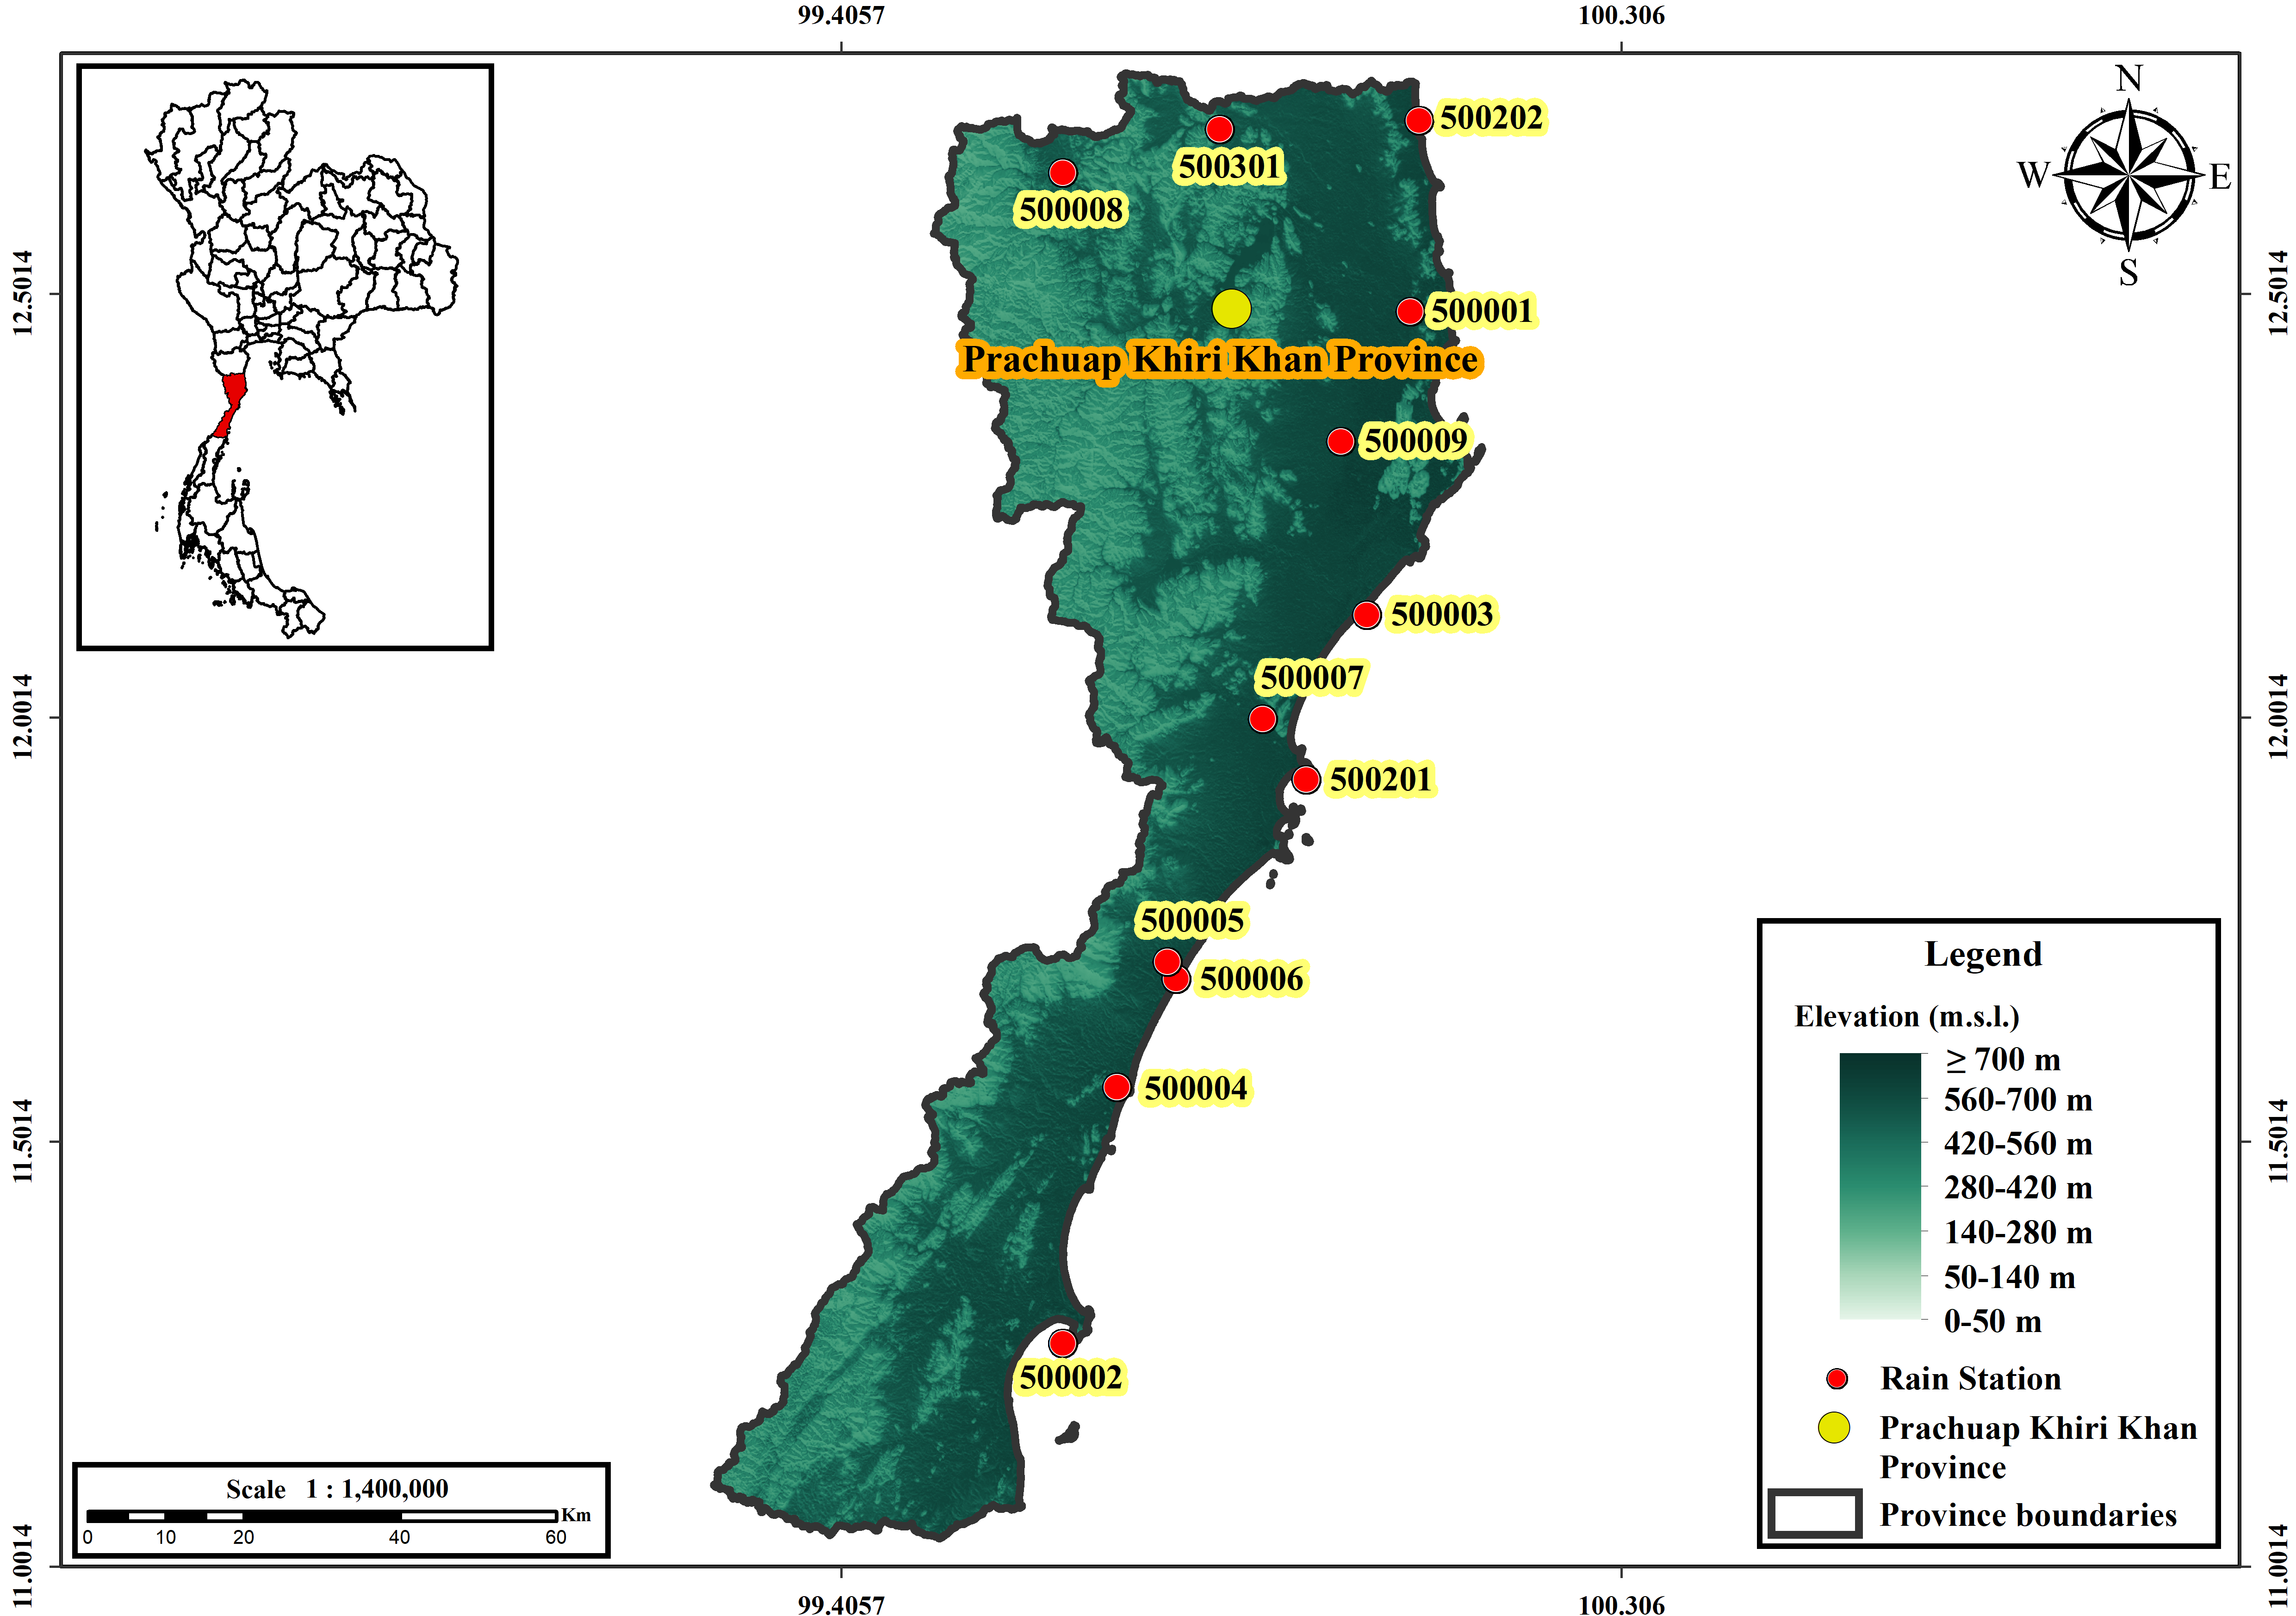
Figure 1. Location of the 12 rain gauges in Prachuap Khiri Khan Province, Thailand. Red circles mark gauge locations and labels identify the stations. Background shading represents elevation classes, and the inset shows the province's location within Thailand.

2.2 Climate models and experimental design
Seven CMIP6 models supplied daily precipitation for the gauge locations (Table 2). Ensemble-member and grid labels were verified against the archive filenames. CESM2 used r11i1p1f1; the other six models used r1i1p1f1.
A single split was used for every method: 1981-2000 for calibration and 2001-2014 for independent validation. Validation observations were not used during fitting. All comparisons were restricted to the same 12 gauges.

Model | Institution | Ensemble member | Grid label
ACCESS-ESM1-5 | CSIRO, Australia | r1i1p1f1 | gn
CanESM5 | CCCma, Canada | r1i1p1f1 | gn
CESM2 | NCAR, United States | r11i1p1f1 | gn
EC-Earth3 | EC-Earth Consortium, Europe | r1i1p1f1 | gr
FGOALS-g3 | CAS, China | r1i1p1f1 | gn
MIROC6 | MIROC, Japan | r1i1p1f1 | gn
MRI-ESM2-0 | MRI, Japan | r1i1p1f1 | gn
Table 2. The seven CMIP6 models and their configuration.
All seven models provide daily precipitation for the historical experiment (1981–2014) and for both SSP2-4.5 and SSP5-8.5. Labels were verified against the archive filenames. gn = native model grid; gr = regridded.

2.3 Bias-correction methods
Quantile delta mapping (QDM) was applied independently to each gauge and calendar month. Let $F_{o}$and $F_{m}$denote the empirical cumulative distribution functions of observed and simulated precipitation during the calibration period, respectively. For a simulated value $x$, its model quantile was first determined as
$$\begin{matrix} & u=F_{m}\left(x\right), & & \text{(7)}\end{matrix}$$
and the corresponding observed quantile was obtained from the inverse observed distribution. For relative QDM, the bias-corrected value was calculated as
$$\begin{matrix} & x_{QDM}=F_{o}^{-1}\left(u\right)\frac{x}{F_{m,b}^{-1}\left(u\right)}, & & \text{(8)}\end{matrix}$$
where $F_{m,b}^{-1}\left(u\right)$is the model quantile at the same probability during the baseline period. This formulation preserves the relative model-projected change at each quantile [4].
MBCn was initialized with the QDM-corrected precipitation field and subsequently applied iterative multivariate adjustments [8]. At each pass, the 12-station precipitation vectors were transformed using a seeded random orthogonal rotation,
$$\begin{matrix} & Z^{\left(k\right)}=P^{\left(k\right)}R^{\left(k\right)}, R^{\left(k\right)}{R^{\left(k\right)}}^{T}=I, & & \text{(9)}\end{matrix}$$
where $P^{\left(k\right)}$is the precipitation field entering pass $k$, $R^{\left(k\right)}$is a random orthogonal rotation matrix, and $Z^{\left(k\right)}$is the rotated field. Each rotated component was then quantile-mapped to the corresponding rotated observational component, after which the inverse rotation was applied. This procedure was repeated for 25 passes. The final rank-substitution step restored the QDM-corrected value at each gauge while retaining the multivariate adjustment in the arrangement of values across stations. Thus, MBCn was designed to preserve the QDM marginal distributions while modifying inter-station dependence (Figure 2). The importance of evaluating multistation dependence in addition to marginal performance has also been emphasized in previous comparisons [19].
All QDM mappings, orthogonal rotations, and rotated-space mappings were fitted using the 1981–2000 calibration period only. The 2001–2014 observations were withheld for independent evaluation. A wet day was defined as a daily precipitation amount of $≥1$mm. Thresholds for the extreme-precipitation diagnostics were estimated separately from the wet-day values of each series. This treatment ensured that the subsequent dependence diagnostics primarily assessed the ability of the correction methods to reproduce the observed spatial dependence structure rather than differences in marginal precipitation intensity.
.
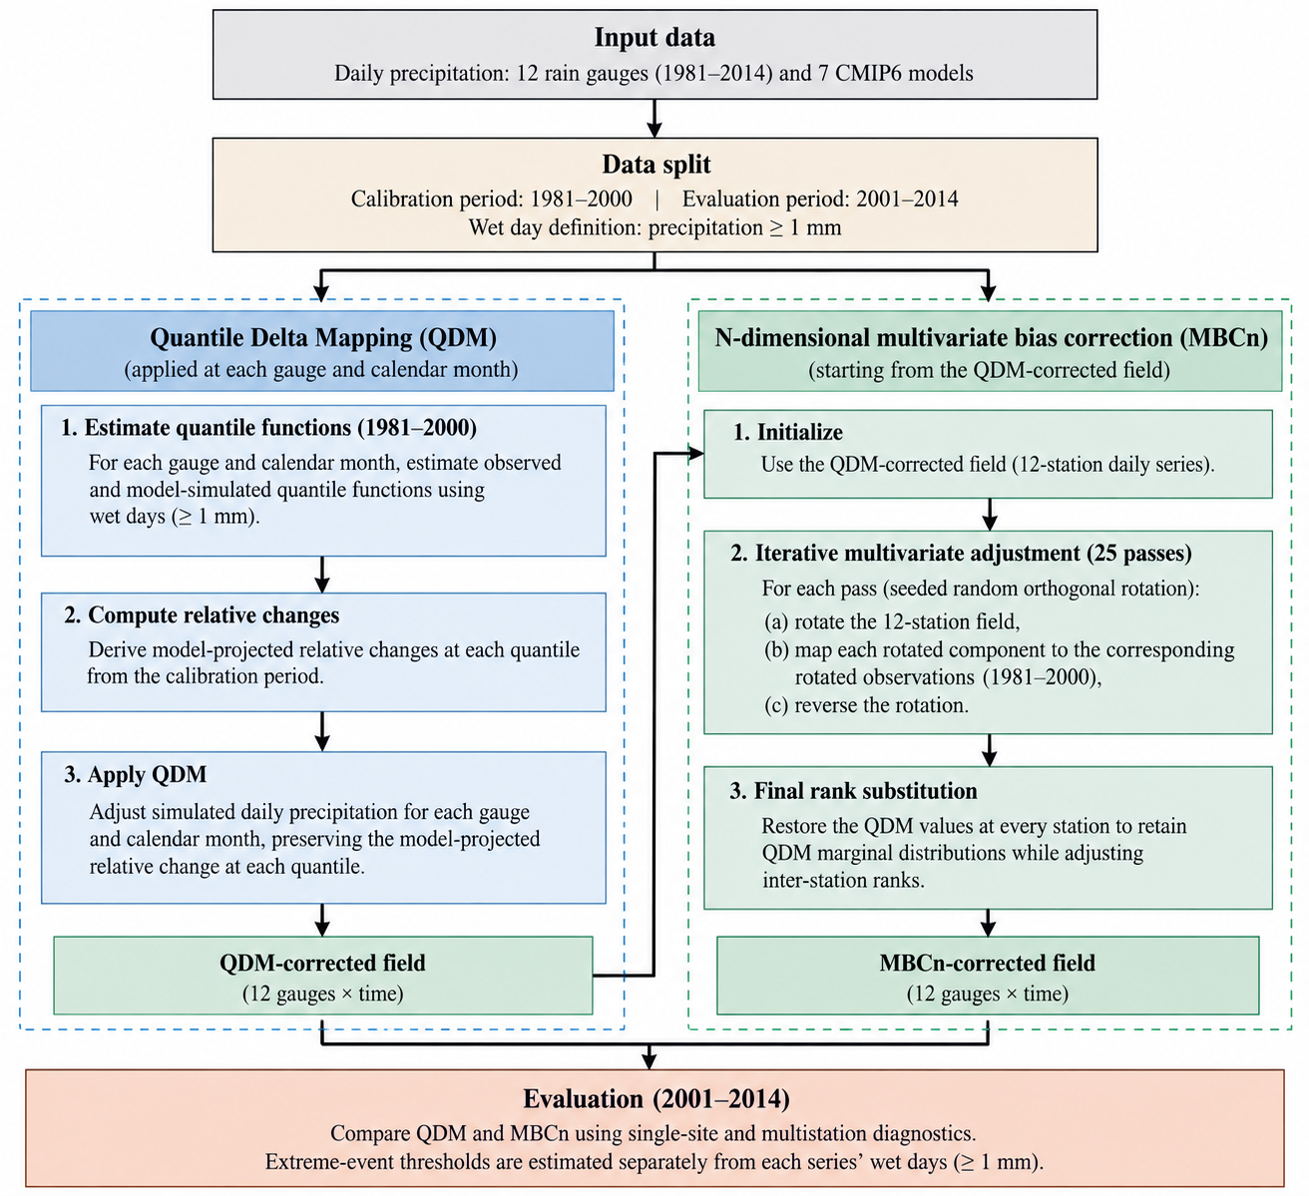
Figure 2. MBCn workflow. QDM [4] first establishes each gauge's marginal distribution; the iterative rotation, mapping, and inverse-rotation stage [8] adjusts inter-station dependence; final rank substitution restores the QDM values. All transformations are fitted using calibration data only.

2.4 Single-site diagnostics
Because free-running climate simulations are not expected to reproduce the timing of individual observed rainfall events, model performance was evaluated using distributional rather than day-matched diagnostics. For each of the 84 gauge–model combinations, six complementary metrics were calculated over the independent validation period: percentage bias in total precipitation (PBIAS), wet-day-frequency error, the ratio of simulated to observed wet-day standard deviation (SD ratio), Perkins skill score (PSS), Kolmogorov–Smirnov (KS) distance, and the root mean square error (RMSE) of matched wet-day quantiles. The diagnostics were selected to assess complementary aspects of precipitation amount, occurrence, variability, distributional shape, and quantile agreement. Perkins skill score follows the probability-density-overlap approach of Perkins et al. [20].
A wet day was defined as a day with precipitation ≥1 mm. Let $O_{t}$and $M_{t}$denote observed and simulated precipitation on day $t$, respectively, and let $N$be the number of validation days. Total-precipitation bias was expressed as
$$\begin{matrix} & PBIAS=100 \frac{\sum_{t=1}^{N}{M_{t}}-\sum_{t=1}^{N}{O_{t}}}{\sum_{t=1}^{N}{O_{t}}}, & & \text{(1)}\end{matrix}$$
where values close to zero indicate smaller bias; positive and negative values indicate overestimation and underestimation, respectively.
Wet-day-frequency error was calculated in percentage points as
$$\begin{matrix} & E_{wet}=100\left(\frac{N_{M}^{wet}}{N}-\frac{N_{O}^{wet}}{N}\right), & & \text{(2)}\end{matrix}$$
where $N_{M}^{wet}$and $N_{O}^{wet}$are the numbers of simulated and observed wet days, respectively. The wet-day standard-deviation ratio was defined as
$$\begin{matrix} & R_{SD}=\frac{σ_{M}^{wet}}{σ_{O}^{wet}}, & & \text{(3)}\end{matrix}$$
where $σ_{M}^{wet}$and $σ_{O}^{wet}$are the standard deviations of simulated and observed precipitation restricted to wet days. A value of one therefore indicates agreement in wet-day variability.
To evaluate the overall distributional shape, the Perkins skill score was calculated from the simulated and observed precipitation probability distributions using common bins:
$$\begin{matrix} & PSS=\sum_{k=1}^{K}{min}\left(p_{M,k} , p_{O,k}\right), & & \text{(4)}\end{matrix}$$
where $p_{M,k}$and $p_{O,k}$are the simulated and observed probabilities in precipitation bin $k$, and $K$is the total number of common bins. PSS ranges from 0 to 1, with values closer to 1 indicating greater overlap between the two distributions. For distributional agreement based on the cumulative distribution functions (CDFs), the KS distance was calculated as
$$\begin{matrix} & D_{KS}=\sup_{x}∣F_{M}\left(x\right)-F_{O}\left(x\right)∣, & & \text{(5)}\end{matrix}$$
where $F_{M}\left(x\right)$and $F_{O}\left(x\right)$are the simulated and observed CDFs, respectively. Lower values indicate closer agreement.
Finally, agreement across the magnitude range of wet-day precipitation was evaluated using matched quantiles. For a set of quantile probabilities $p_{j}$, $j=1,…,J$, the quantile RMSE was calculated as
$$\begin{matrix} & {RMSE}_{q}=\sqrt{\frac{1}{J}\sum_{j=1}^{J}{{\left[Q_{M}\left(p_{j}\right)-Q_{O}\left(p_{j}\right)\right]}^{2}}}, & & \text{(6)}\end{matrix}$$
where $Q_{M}\left(p_{j}\right)$and $Q_{O}\left(p_{j}\right)$are the simulated and observed wet-day quantiles at probability $p_{j}$. Lower values indicate closer agreement in precipitation magnitude across the selected quantiles.
Together, these metrics provide a distribution-based assessment without requiring correspondence between simulated and observed rainfall on the same calendar day. Day-matched error measures were therefore not used, as they would confound distributional model skill with differences in the timing of weather events that free-running climate simulations are not designed to reproduce. This distribution-focused evaluation is also consistent with the use of probability distributions and precipitation-frequency characteristics in previous climate-model evaluations.

2.5 Dependence diagnostics and statistical testing
The ability of the correction methods to reproduce the spatial dependence of daily precipitation was evaluated using six complementary diagnostics. For each climate model, the corrected 12-station precipitation field was compared with the observations over the withheld validation period. The diagnostics comprised energy distance, RMSE of the inter-station Spearman correlation matrix, RMSE of the Pearson correlation matrix, RMSE of binary wet-day correlation, RMSE of concurrent exceedance probabilities, and the Wasserstein-1 distance between distributions of daily wet-station extent. Thus, the evaluation focused on the joint structure of precipitation rather than on marginal distributions, which were assessed separately in Section 2.4. The six diagnostics were calculated independently for each of the seven climate models.
Let $X_{t}=\left(X_{t1} , … , X_{t12}\right)$and $Y_{t}=\left(Y_{t1} , … , Y_{t12}\right)$denote the observed and simulated 12-dimensional precipitation vectors on day $t$, respectively. Energy distance was used as a multivariate measure of overall distributional discrepancy [21]:
$$\begin{matrix} & D_{E}=2 E∥X-Y∥-E∥X-X^{'}∥-E∥Y-Y^{'}∥, & & \text{(7)}\end{matrix}$$
where $X^{'}$and $Y^{'}$are independent copies of $X$and $Y$, respectively, and $∥⋅∥$denotes the Euclidean norm. The statistic approaches zero as the two multivariate distributions become more similar. Following the analysis design, energy distance was calculated using a fixed-seed subsample of at most 1,500 validation days to provide a reproducible comparison while limiting computational cost. The energy-distance formulation follows Székely and Rizzo [21].
Dependence among stations was further evaluated from the three $12×12$correlation matrices: Spearman rank correlation, Pearson correlation, and binary wet-day correlation. Because the diagonal elements represent self-correlations and do not contain information about inter-station dependence, only the 66 unique off-diagonal station pairs were evaluated. For a given correlation measure $r$, the corresponding matrix RMSE was calculated as
$$\begin{matrix} & {RMSE}_{r}={\left[\frac{1}{66}\sum_{i<j}{{\left(r_{ij}^{M}-r_{ij}^{O}\right)}^{2}}\right]}^{1/2}, & & \text{(8)}\end{matrix}$$
where $r_{ij}^{M}$and $r_{ij}^{O}$denote the simulated and observed correlations for station pair $\left(i , j\right)$, respectively. For the wet-day correlation, precipitation at each station was converted to a binary indicator
$$\begin{matrix} & W_{ti}=\left\{\begin{matrix}1, & P_{ti}≥1 mm, \\ 0, & P_{ti}<1 mm,\end{matrix}\right. & & \text{(9)}\end{matrix}$$
consistent with the wet-day definition used throughout the analysis. The resulting binary series were then used to calculate pairwise correlations. The three correlation-based RMSEs were treated as the prespecified primary dependence endpoints, consistent with the statistical testing framework of the study.
Concurrent precipitation extremes were assessed by comparing the probability that two stations simultaneously exceeded their respective 95th wet-day precipitation percentiles. For station pair $\left(i , j\right)$, the joint exceedance probability was defined as
$$\begin{matrix} & J_{ij}=\frac{1}{N}\sum_{t=1}^{N}{I}\left(P_{ti}>q_{i,0.95}\right)I\left(P_{tj}>q_{j,0.95}\right), & & \text{(10)}\end{matrix}$$
where $q_{i,0.95}$and $q_{j,0.95}$are the station-specific 95th percentiles of wet-day precipitation and $I\left(⋅\right)$is the indicator function. The corresponding discrepancy was summarized over the 66 station pairs as
$$\begin{matrix} & {RMSE}_{J}={\left[\frac{1}{66}\sum_{i<j}{{\left(J_{ij}^{M}-J_{ij}^{O}\right)}^{2}}\right]}^{1/2}. & & \text{(11)}\end{matrix}$$
This metric evaluates whether the correction method reproduces the spatial occurrence of concurrent heavy precipitation rather than the frequency of extreme precipitation at individual stations. The use of each station's own 95th wet-day percentile follows the study design and minimizes the influence of residual marginal differences on the dependence assessment.
At the network scale, the spatial extent of daily wet conditions was represented by the number of stations recording precipitation of at least 1 mm on each day,
$$\begin{matrix} & H_{t}=\sum_{i=1}^{12}{I}\left(P_{ti}≥1 mm\right). & & \text{(12)}\end{matrix}$$
The distributions of $H_{t}$from the simulations and observations were compared using the Wasserstein-1 distance,
$$\begin{matrix} & W_{1}\left(F_{M} , F_{O}\right)=\int_{-∞}^{∞}{∣F_{M}\left(h\right)-F_{O}\left(h\right)∣} dh, & & \text{(13)}\end{matrix}$$
where $F_{M}$and $F_{O}$are the empirical cumulative distribution functions of daily wet-station extent for the simulated and observed fields, respectively. Lower values indicate closer agreement in the spatial coverage of wet conditions. This network-scale metric complements the pairwise joint-exceedance measure by evaluating the overall distribution of wet-station extent rather than the identity of particular station pairs.
All six diagnostics were oriented such that smaller values indicate better agreement with observations. The resulting scores were retained separately for each climate model and were subsequently used to compare MBCn with QDM. This distinction is important because the final rank-substitution step of MBCn restores the QDM marginal values at each station; consequently, differences between the two methods are expected to emerge primarily in dependence-related diagnostics rather than in the single-site distributions.
For formal comparison, the seven model-level scores from MBCn and QDM were treated as matched observations. For each diagnostic, the paired difference was defined as
$$\begin{matrix} & d_{m}=S_{m}^{QDM}-S_{m}^{MBCn}, m=1,…,7, & & \text{(14)}\end{matrix}$$
so that $d_{m}>0$indicates an improvement with MBCn because all dependence diagnostics are negatively oriented. A one-sided exact Wilcoxon signed-rank test was then applied to the seven paired differences. The analysis tests whether the observed within-ensemble differences consistently favour MBCn; it is not intended to provide inference to a broader population of climate models. The strength and direction of the paired effect were additionally summarized using the matched-pairs rank-biserial correlation,
$$\begin{matrix} & r_{rb}=\frac{W^{+}-W^{-}}{W^{+}+W^{-}}, & & \text{(15)}\end{matrix}$$
where $W^{+}$and $W^{-}$are the sums of the positive and negative signed ranks, respectively. Values approaching $+1$indicate that the paired differences consistently favour MBCn under the definition in Eq. (14). The number of models for which MBCn produced the lower diagnostic value was also reported to make the direction of the model-level comparison explicit. In the present seven-model ensemble, this paired framework yielded a maximum possible rank-biserial effect size when all models favoured MBCn.
Because Spearman, Pearson, and wet-day-correlation RMSE were specified a priori as the primary correlation endpoints, their $p$-values were adjusted for multiple testing using the Holm–Bonferroni procedure. If $p_{\left(1\right)}≤⋯≤p_{\left(m\right)}$are the ordered $mp$-values, the adjusted values are obtained sequentially as
$$\begin{matrix} & p_{\left(i\right)}^{ adj}=\min\left[1 , \max_{k≤i}\left\{\left(m-k+1\right)p_{\left(k\right)}\right\}\right]. & & \text{(16)}\end{matrix}$$
The remaining diagnostics—energy distance, joint-exceedance RMSE, and wet-extent $W_{1}$—were regarded as secondary or exploratory endpoints and were reported without adjustment. This preserves the prespecified inferential structure of the study while avoiding an implicit claim that all six diagnostics constitute independent tests.

2.6 Robustness checks
Robustness was assessed from two aspects: sensitivity to the number of MBCn adjustment passes and sensitivity to random initialization. The number of adjustment passes was varied from 0 to 100, with zero passes representing QDM. The selected dependence diagnostics were examined as a function of the number of passes to identify the range over which the results became stable. The default 25-pass configuration was then repeated using 20 random seeds to evaluate the sensitivity of the results to stochastic initialization.
The preservation of the model-projected precipitation-change signal was assessed using five selected wet-day precipitation quantiles. For each gauge, climate model, pathway, future period, and quantile $p$, the projected percentage change was calculated as
$$\begin{matrix} & ΔQ_{p}=100\left(\frac{Q_{p,f}-Q_{p,b}}{Q_{p,b}}\right), & & \text{(17)}\end{matrix}$$
where $Q_{p,b}$and $Q_{p,f}$denote the $p$-th wet-day precipitation quantiles during the baseline and future periods, respectively.
The deviation of the bias-corrected change signal from the corresponding raw model signal was quantified using the mean absolute deviation (MAD):
$$\begin{matrix} & MAD=\frac{1}{N}\sum_{i=1}^{N}{∣ΔQ_{p,i}^{C}-ΔQ_{p,i}^{R}∣}, & & \text{(18)}\end{matrix}$$
where $ΔQ_{p,i}^{C}$and $ΔQ_{p,i}^{R}$are the projected percentage changes after bias correction and from the raw climate-model output, respectively, and $N$is the total number of gauge–model–pathway–period–quantile combinations.
Agreement between the corrected and raw projected changes was additionally quantified using the coefficient of determination:
$$\begin{matrix} & R^{2}=1-\frac{\sum_{i=1}^{N}{{\left(ΔQ_{p,i}^{C}-ΔQ_{p,i}^{R}\right)}^{2}}}{\sum_{i=1}^{N}{{\left(ΔQ_{p,i}^{R}-\overset{‾}{ΔQ_{p}^{R}}\right)}^{2}}}, & & \text{(19)}\end{matrix}$$
where $\overset{‾}{ΔQ_{p}^{R}}$is the mean raw projected percentage change across all comparison cases.
These robustness checks were used to assess numerical stability, sensitivity to random initialization, and preservation of the model-projected quantile-change signal. They do not constitute validation of future projections against observations and do not assess sequence-dependent characteristics such as wet- and dry-spell persistence.

3. Results and Discussion

3.1 Single-site performance is identical between the two corrections
The raw output produced rain too frequently and underestimated wet-day variability (Table 3 and Figure 3). After correction, Kolmogorov-Smirnov distance decreased from 0.221 to 0.101 and Perkins skill score increased from 0.82 to 0.91. Both corrections retained an approximately 17% dry bias in total precipitation and a wet-day-frequency bias of about -6 percentage points; this residual bias should be considered in water-balance applications.
QDM and MBCn were identical to three decimal places for every marginal score across all 84 gauge-model combinations. This confirms the expected algorithmic behaviour: final rank substitution returns the same set of daily QDM values at each gauge. The multivariate stage can therefore affect only how values are arranged jointly across the network, not their station-level distributions.

Method | PBIAS (%) | Wet-day frequency error (pp) | SD ratio (–) | PSS (–) | KS distance (–) | Quantile RMSE (mm d⁻¹)
RAW | RE-RUN | RE-RUN | RE-RUN | RE-RUN | RE-RUN | RE-RUN
QDM | RE-RUN | RE-RUN | RE-RUN | RE-RUN | RE-RUN | RE-RUN
MBCn | RE-RUN | RE-RUN | RE-RUN | RE-RUN | RE-RUN | RE-RUN
Table 3. Single-site skill over the withheld validation period (mean ± SD, n = 84 gauge–model pairs).
pp = percentage points; PSS = Perkins skill score; KS = Kolmogorov–Smirnov; SD ratio is the corrected-to-observed ratio of the wet-day standard deviation. QDM and MBCn coincide on every score because MBCn reinstates the QDM value at each gauge.
Figure 3. To be regenerated from the Q2.1 station-locked validation outputs.

MBCn was initialized with the QDM-corrected precipitation field and subsequently applied iterative multivariate adjustments [8]. In the revised Q2.1 implementation, the transformation is performed within calendar-month blocks so that seasonal precipitation structure is not pooled across months. For each month, the 12-station precipitation vectors are standardized using the observed calibration mean and standard deviation, transformed with a deterministic seeded random orthogonal rotation, quantile-mapped component by component in rotated space, and transformed back. Twenty-five passes are used in the production configuration. The final rank-substitution step restores the QDM-corrected values at each station within the corresponding month, so MBCn is intended to preserve the exact station-wise QDM marginal sample while altering its cross-station arrangement.
MBCn outperformed QDM for every dependence diagnostic (Table 4). Energy distance decreased from 0.852 for QDM to 0.571 for MBCn. Spearman correlation-matrix RMSE decreased from 0.484 in raw output to 0.286 with QDM and to 0.187 with MBCn. Pearson correlation, wet-day correlation, joint 95th-percentile exceedance, and wet-extent distribution showed the same ordering.
Every model improved under MBCn for all six diagnostics (Table 5). With seven concordant non-zero paired differences, the one-sided exact Wilcoxon p-value was 0.0078, the smallest attainable value at n = 7, and the matched-pairs rank-biserial effect size was 1.00. Holm-Bonferroni-adjusted p-values for the three prespecified correlation endpoints were 0.0234. These values summarize a unanimous within-ensemble pattern; the models are not a random sample, and the six diagnostics are related views of the same dependence improvement.
The model-level results show that the ensemble mean was not driven by a small number of influential models. The seven-of-seven improvement in Table 5 occurred for energy distance, three correlation measures, joint-exceedance error, and wet-extent distance. Agreement across these related diagnostics indicates that MBCn improved several features of the joint precipitation structure rather than a single summary statistic.
Spatially, pairwise Spearman correlation declined modestly with gauge separation in the observations (Figure 4). Raw output remained near 0.96 across most distances, indicating pronounced over-coherence. QDM reduced this bias, whereas MBCn most closely followed the observed distance relationship. Some raw over-coherence is expected when gauges share or occupy adjacent coarse grid cells. The binned relationship and bootstrap bands are descriptive because the 66 gauge pairs are not independent.

Method | Std. energy distance | Spearman RMSE | Pearson RMSE | Wet-occurrence RMSE | Joint q95 RMSE | Wet-extent W₁
RAW | RE-RUN | RE-RUN | RE-RUN | RE-RUN | RE-RUN | RE-RUN
QDM | RE-RUN | RE-RUN | RE-RUN | RE-RUN | RE-RUN | RE-RUN
MBCn | RE-RUN | RE-RUN | RE-RUN | RE-RUN | RE-RUN | RE-RUN
The final rank-substitution step restores the QDM-corrected value set at each gauge within each calendar-month block while retaining the multivariate adjustment in the arrangement of values across stations. Consequently, marginal diagnostics are expected to be identical by construction, whereas dependence diagnostics can differ. This property will be verified after the Q2.1 caches are rebuilt.
Values are means of per-model scores. The energy distance is the broadest whole-distribution measure, computed on a fixed-seed random subsample of at most 1,500 days; the correlation-matrix RMSEs, the joint-exceedance RMSE and the wet-extent Wasserstein-1 distance (W₁) are structure diagnostics. Joint exceedance uses each series' own wet-day ninety-fifth percentile and wet extent the 1 mm threshold. MBCn is closest to observations on every diagnostic. All quantities are dimensionless.

Diagnostic | Models favouring MBCn | W | p | Holm-adjusted p | Effect size
Std. energy distance (secondary) | RE-RUN | RE-RUN | RE-RUN | RE-RUN | RE-RUN
Spearman RMSE (primary) | RE-RUN | RE-RUN | RE-RUN | RE-RUN | RE-RUN
Pearson RMSE (primary) | RE-RUN | RE-RUN | RE-RUN | RE-RUN | RE-RUN
Wet-day co-occurrence RMSE (primary) | RE-RUN | RE-RUN | RE-RUN | RE-RUN | RE-RUN
Joint q95 exceedance RMSE (secondary) | RE-RUN | RE-RUN | RE-RUN | RE-RUN | RE-RUN
Wet-extent W₁ (secondary) | RE-RUN | RE-RUN | RE-RUN | RE-RUN | RE-RUN
Table 5. Paired comparison of MBCn against QDM across the seven models (one-sided Wilcoxon signed-rank test; Holm–Bonferroni adjustment within the correlation-endpoint family).
Every model improves under MBCn on every diagnostic, yielding the maximum matched-pairs rank-biserial effect size and the smallest p attainable at n = 7. The Holm adjustment covers the three pre-declared correlation endpoints; the remaining diagnostics are exploratory and reported unadjusted.
All QDM mappings, orthogonal rotations, and rotated-space mappings are fitted using the 1981–2000 calibration period only. The 2001–2014 observations are withheld for independent validation. A wet day is defined as precipitation ≥1 mm. Extreme-precipitation thresholds are estimated from wet-day values according to the diagnostic definition. For the dependence-focused joint-tail metric, each station uses its own method-specific wet-day 95th percentile and the resulting probabilities are normalized by the corresponding marginal exceedance probabilities; an additional observed-threshold version is retained as a hazard-oriented sensitivity diagnostic. The revised analysis also reports station-standardized energy distance so that the multivariate distance is not dominated by station magnitude and unit scale.
Figure 4. To be regenerated from the Q2.1 distance-decay analysis.

3.3 Spatial organisation of concurrent extremes
Concurrent-extreme diagnostics led to the same ordering. Figure 5 compares observed and simulated probabilities that both gauges in a pair exceeded their own 95th wet-day percentiles on the same date. Raw output was widely dispersed, QDM retained a positive bias, and MBCn lay closest to the 1:1 line without a systematic tilt.
Wet extent provides a network-scale complement to the pairwise exceedance diagnostic. The mean per-model Wasserstein-1 distance decreased from 0.107 for QDM to 0.079 for MBCn (Table 4), and all seven models improved (Table 5). MBCn therefore reproduced the daily spatial coverage of wet conditions more closely, although this metric does not identify where within the network the wet gauges occurred.
Figure 5. To be regenerated using the revised normalized and observed-threshold q95 diagnostics.

3.4 Numerical behaviour and fidelity to the projected change signal
Iteration and seed experiments showed that the multivariate adjustment was numerically stable. Most improvement occurred within 10-15 passes, after which the diagnostics oscillated within a narrow range; the 25-pass default therefore lay on the convergence plateau. Across 20 random seeds, correlation-based scores changed little, with a coefficient of variation of approximately 4%. Energy distance varied more because it used fixed-size random subsamples, whereas the full-sample correlation diagnostics remained stable.
Projected wet-day quantile changes were similarly preserved by both methods (Figure 6). Across all gauges, models, pathways, and future periods, mean absolute deviation from the raw change signal was 9.4 percentage points for QDM and 9.2 for MBCn; the corresponding R-squared values were 0.485 and 0.465. MBCn therefore improved dependence without a material additional loss of QDM's change-preservation property [4]. This check does not cover sequence-dependent statistics, such as wet- and dry-spell lengths, which MBCn may alter.
Figure 6. To be regenerated from the Q2.1 climate-signal preservation analysis using the method-consistent baseline.

3.5 Implications and limitations
The results support a context-specific choice rather than a universal ranking. Recent comparisons likewise show that no bias-correction method dominates every temporal and dependence property [22]; method selection should follow the structure required by the downstream application. QDM is sufficient and less computationally demanding when only single-site distributions are required, including many intensity-duration-frequency applications in Thailand [23] and basin-scale drought-risk assessments [24]. MBCn is better supported when gauges are used jointly in distributed hydrological modelling, spatial hazard mapping, or multivariate risk analysis.
More broadly, station-wise evaluation cannot distinguish methods that share marginal distributions but differ in joint behaviour. At least one dependence diagnostic should accompany conventional marginal scores whenever corrected variables or locations will be analysed together.
Four limitations bound the conclusions. One realization per model does not represent internal variability. The single coastal network may not represent inland or more strongly monsoonal settings. The stationary calibration assumes that historical dependence remains an appropriate target under future climate. Finally, the residual dry bias in both corrections limits water-balance applications. These limitations constrain generalization but do not affect the paired comparison, for which both methods used identical inputs and periods.

4. Conclusion
Across 12 coastal gauges and seven CMIP6 models, QDM and MBCn were identical for all six station-level diagnostics because MBCn restored the QDM marginal values. In contrast, MBCn improved all six dependence diagnostics for every model, reducing energy distance and correlation-structure errors while converging rapidly, remaining insensitive to random seed, and preserving projected wet-day quantile changes comparably to QDM. QDM therefore remains appropriate when only marginal fidelity is needed; MBCn is the better-supported choice when inter-station dependence is part of the scientific or hydrological question. Dependence diagnostics should become routine whenever corrected locations are used jointly. Evaluation across larger, topographically diverse networks and multi-realization ensembles is the next step for testing the generality of these findings.

Acknowledgment
The author gratefully acknowledges the Thai Meteorological Department (TMD) for providing observed daily precipitation records.

Author Contributions
Surasit Punyawansiri: conceptualization, methodology, software, validation, formal analysis, investigation, resources, data curation, writing - original draft, writing - review and editing, visualization, supervision, and project administration. The author has read and approved the submitted manuscript.

Funding
This research received no external funding.

Conflicts of Interest
The author declares no conflict of interest.

Data and Code Availability
The daily rain-gauge records are available from the Royal Irrigation Department subject to its data-sharing conditions. CMIP6 output is publicly available through the Earth System Grid Federation. Analysis code and underlying numerical data for the figures are available from the corresponding author on reasonable request.

References
[1] D. Maraun, "Bias correcting climate change simulations - a critical review," Curr. Clim. Change Rep., vol. 2, no. 4, pp. 211-220, 2016, doi: 10.1007/s40641-016-0050-x.
[2] C. Teutschbein and J. Seibert, "Bias correction of regional climate model simulations for hydrological climate-change impact studies: Review and evaluation of different methods," J. Hydrol., vols. 456-457, pp. 12-29, 2012, doi: 10.1016/j.jhydrol.2012.05.052.
[3] L. Gudmundsson, J. B. Bremnes, J. E. Haugen, and T. Engen-Skaugen, "Technical Note: Downscaling RCM precipitation to the station scale using statistical transformations - a comparison of methods," Hydrol. Earth Syst. Sci., vol. 16, no. 9, pp. 3383-3390, 2012, doi: 10.5194/hess-16-3383-2012.
[4] A. J. Cannon, S. R. Sobie, and T. Q. Murdock, "Bias correction of GCM precipitation by quantile mapping: How well do methods preserve changes in quantiles and extremes?" J. Clim., vol. 28, no. 17, pp. 6938-6959, 2015, doi: 10.1175/JCLI-D-14-00754.1.
[5] E. Bevacqua et al., "Advancing research on compound weather and climate events via large ensemble model simulations," Nat. Commun., vol. 14, Art. no. 2145, 2023, doi: 10.1038/s41467-023-37847-5.
[6] M. Vrac, "Multivariate bias adjustment of high-dimensional climate simulations: The Rank Resampling for Distributions and Dependences (R2D2) bias correction," Hydrol. Earth Syst. Sci., vol. 22, no. 6, pp. 3175-3196, 2018, doi: 10.5194/hess-22-3175-2018.
[7] Y. Robin, M. Vrac, P. Naveau, and P. Yiou, "Multivariate stochastic bias corrections with optimal transport," Hydrol. Earth Syst. Sci., vol. 23, no. 2, pp. 773-786, 2019, doi: 10.5194/hess-23-773-2019.
[8] A. J. Cannon, "Multivariate quantile mapping bias correction: An N-dimensional probability density function transform for climate model simulations of multiple variables," Clim. Dyn., vol. 50, nos. 1-2, pp. 31-49, 2018, doi: 10.1007/s00382-017-3580-6.
[9] B. François, M. Vrac, A. J. Cannon, Y. Robin, and D. Allard, "Multivariate bias corrections of climate simulations: Which benefits for which losses?" Earth Syst. Dyn., vol. 11, no. 2, pp. 537-562, 2020, doi: 10.5194/esd-11-537-2020.
[10] D. Dieng et al., "Multivariate bias-correction of high-resolution regional climate change simulations for West Africa: Performance and climate change implications," J. Geophys. Res. Atmos., vol. 127, no. 8, Art. no. e2021JD034836, 2022, doi: 10.1029/2021JD034836.
[11] S. I. Seneviratne et al., "Weather and climate extreme events in a changing climate," in Climate Change 2021: The Physical Science Basis, Cambridge, U.K.: Cambridge Univ. Press, 2021, pp. 1513-1766, doi: 10.1017/9781009157896.013.
[12] S. Supharatid, J. Nafung, and T. Aribarg, "Projected changes in temperature and precipitation over mainland Southeast Asia by CMIP6 models," J. Water Clim. Change, vol. 13, no. 1, pp. 337-356, 2022, doi: 10.2166/wcc.2021.015.
[13] X. Qin and C. Dai, "Comparison of different quantile delta mapping schemes in frequency analysis of precipitation extremes over mainland Southeast Asia under climate change," J. Hydrol., vol. 606, Art. no. 127421, 2022, doi: 10.1016/j.jhydrol.2021.127421.
[14] S. Try and X. Qin, "Evaluation of future changes in climate extremes over Southeast Asia using downscaled CMIP6 GCM projections," Water, vol. 16, no. 15, Art. no. 2207, 2024, doi: 10.3390/w16152207.
[15] U. W. Humphries, M. Waqas, P. T. Hlaing, P. Dechpichai, and A. Wangwongchai, "Assessment of CMIP6 GCMs for selecting a suitable climate model for precipitation projections in Southern Thailand," Results Eng., vol. 23, Art. no. 102417, 2024, doi: 10.1016/j.rineng.2024.102417.
[16] S. Rojpratak and S. Supharatid, "Regional extreme precipitation index: Evaluations and projections from the multi-model ensemble CMIP5 over Thailand," Weather Clim. Extremes, vol. 37, Art. no. 100475, 2022, doi: 10.1016/j.wace.2022.100475.
[17] D. Khadka, M. S. Babel, M. Collins, S. Shrestha, S. G. P. Virdis, and A. S. Chen, "Projected changes in the near-future mean climate and extreme climate events in Northeast Thailand," Int. J. Climatol., vol. 42, no. 4, pp. 2470-2492, 2022, doi: 10.1002/joc.7377.
The ability of the correction methods to reproduce the spatial dependence of daily precipitation was evaluated using six complementary diagnostics. The revised primary endpoints are the RMSEs of the inter-station Spearman rank-correlation matrix, Pearson correlation matrix, and binary wet-day correlation matrix. Secondary diagnostics are station-standardized energy distance, normalized concurrent-q95 exceedance RMSE, an observed-threshold q95 sensitivity diagnostic, and the Wasserstein-1 distance between distributions of daily wet-station extent. All metrics are calculated on the independent 2001–2014 validation period for each of the seven models.
[19] Y. H. Song and E.-S. Chung, "Comparison of quantile mapping methods for daily precipitation correction and future projections under the SSP5-8.5," J. Korea Water Resour. Assoc., vol. 57, no. 12, pp. 1069-1083, 2024, doi: 10.3741/JKWRA.2024.57.12.1069.
[20] S. E. Perkins, A. J. Pitman, N. J. Holbrook, and J. McAneney, "Evaluation of the AR4 climate models' simulated daily maximum temperature, minimum temperature, and precipitation over Australia using probability density functions," J. Clim., vol. 20, no. 17, pp. 4356-4376, 2007, doi: 10.1175/JCLI4253.1.
[21] G. J. Székely and M. L. Rizzo, "Energy statistics: A class of statistics based on distances," J. Stat. Plan. Inference, vol. 143, no. 8, pp. 1249-1272, 2013, doi: 10.1016/j.jspi.2013.03.018.
[22] S. Sharma, A. S. Raghuvanshi, and A. Agarwal, "Evaluating the performance of uni- and multivariate bias correction techniques: Challenges in preserving temporal and dependence structures," Water Resour. Res., vol. 62, no. 2, Art. no. e2025WR041526, 2026, doi: 10.1029/2025WR041526.
[23] K. Tedprasith and W. Lohpaisankrit, "Development of intensity-duration-frequency relationships in Khon Kaen City, Thailand under changing climate using GCMs and a simple scaling method," J. Water Clim. Change, vol. 15, no. 3, pp. 1204-1217, 2024, doi: 10.2166/wcc.2024.533.
[24] J. Srinate and R. Hormwichian, "Modeling future water deficit trends under varying climate change projections in Huai-SamMor Basin, Thailand," Engineering Access, vol. 12, no. 1, pp. 51–62, 2026.
Table 5 (revised status): paired Wilcoxon tests and effect sizes must be recomputed from the seven Q2.1 model-level scores. Holm adjustment applies only to the three primary correlation endpoints.
Table 4 (revised status): standardized energy distance and the revised q95 definition must be recalculated. Previous values are not valid for the Q2.1 implementation.
Table 3 (revised status): all validation values must be regenerated from the Q2.1 station-locked pipeline. Previous numerical values are intentionally removed.

